**Making and mounting solar LED street art images, on high walls.**

<https://www.youtube.com/watch?v=zfhnj6iQW2g&t=41s>

**Introduction**

This guide will explain how to use Solar LED light string to create glowing images and mount these on high walls using an extendable stick. This is good for for places with no electricity like abandoned buildings, and can be used to create psychedelic glowing street art. Solar LEDs basically charged during the day using a solar cell and activated at night to form a glowing image, that never runs out of battery. One of the main goals is to hang the picture as high as possible both for visibility and to make it out of reach for people who might want to take it for the solar cell. For this, we used a modified 3-meter extendable selfie stick, basically a telescopic stick that extends from 0.4 to 3 meters in length. This allows the image to be mounted around 4-6 meters high. The tutorial will be divided into 3 parts:

1) Making a plate with the solar LED light image.

2) Making the hanging stick.

3) Actual hanging.

A video tutorial is also attached and covers everything, we recommend using this as the main source: <https://www.youtube.com/watch?v=zfhnj6iQW2g&t=41s>

**Equipment**

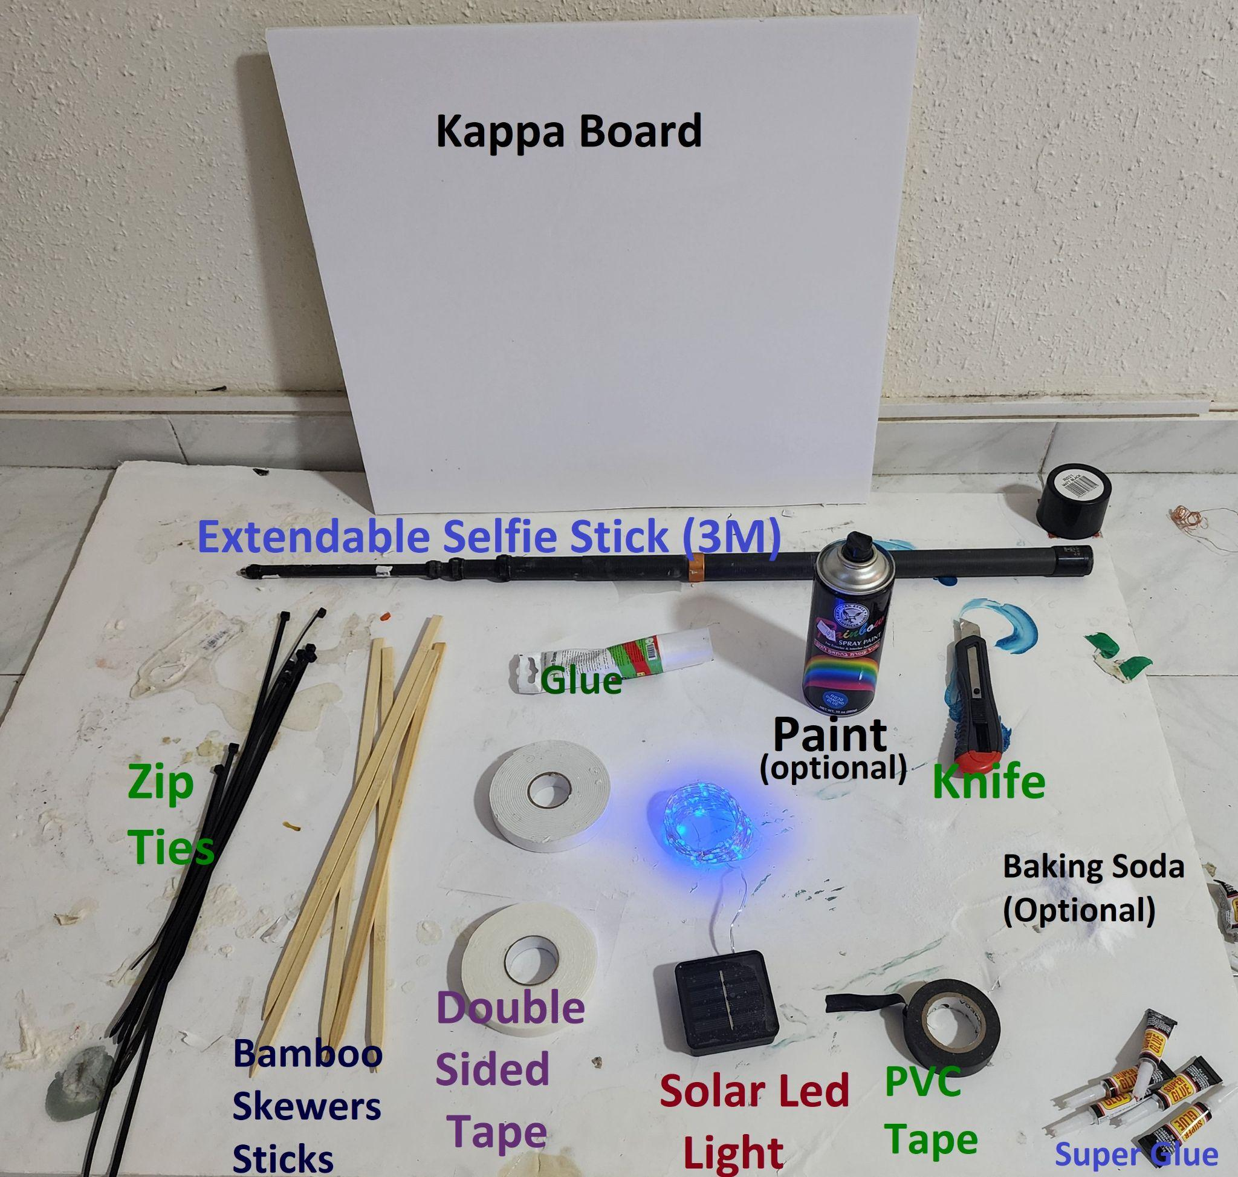

The equipment is pretty basic: The most expensive part is the solar LED that costs about 5-10 USD in Aliexpress. The full set of equipment is shown in the image. For immediate mounting, we used basic foam double-sided mounting tape for fast mounting, combined with glue for long-term permanent attachment. The full list is below:

1. Kappa board (could be found in most art stores). Any rigid lightweight resilient board will do.
2. Solar LED light string (5-15 meters). 5 Meter is easiest to handle and remains active all night. (https://www.aliexpress.com/item/1005004414114222.html?spm=a2g0o.order_list.order_list_main.42.f4441802dI2sXU)
3. A 3-meter extendable selfie stick, the longer the better. (<https://www.aliexpress.com/item/1005005100309521.html?spm=a2g0o.order_list.order_list_main.22.4aec1802jzDyIi>)
4. Basic Double-sided mounting tape thick version. We use cheap foam tape (1-2) dollars per coil. You want a thick version as it sticks better. The paper-thin double-sided sided are NOT recommended.
5. Strong permanent glue in la arge tube, preferably transparent. We use Hybrifix Super 7.
6. Zip Ties (Plastic version from any construction material shop)
7. SuperGlue small tubes.
8. Baking Soda (optional, help harden the super glue).
9. Paint (optional)

**Making Led light image plate.**

**The first thing we want to do is take the LED light string and attach it to the board in a specific shape or image.**

1. Cut the kappa board to the right size (1x1 meter works nicely).
2. Use a pen to draw a simple shape on the board.

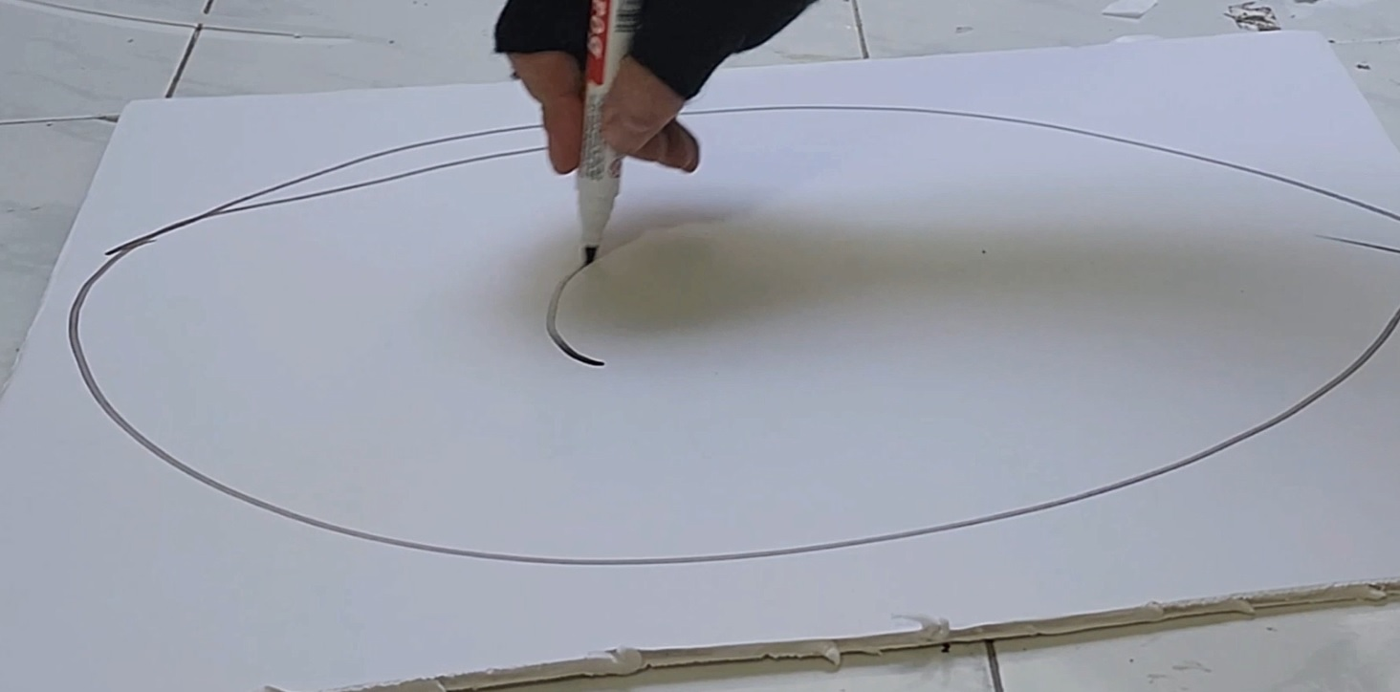

1. Cut pieces of the double-sided tape and scatter them along the shape in a dashed line (this will be used to hold the LED light string to the board).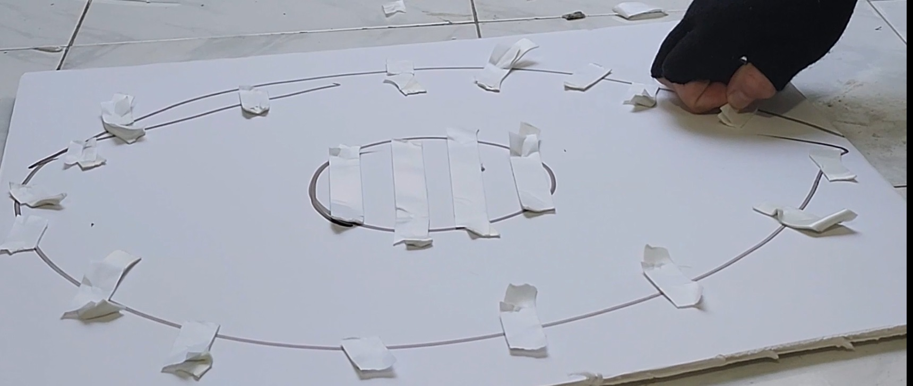
2. Uncover the other side of the double-sided tape you added and then take the led string and attach it to the board along the shape, use the double side tape for mounting (The main issue here is the led string tends to get tangled. Better unwind it and spread it as much as possible before mounting).

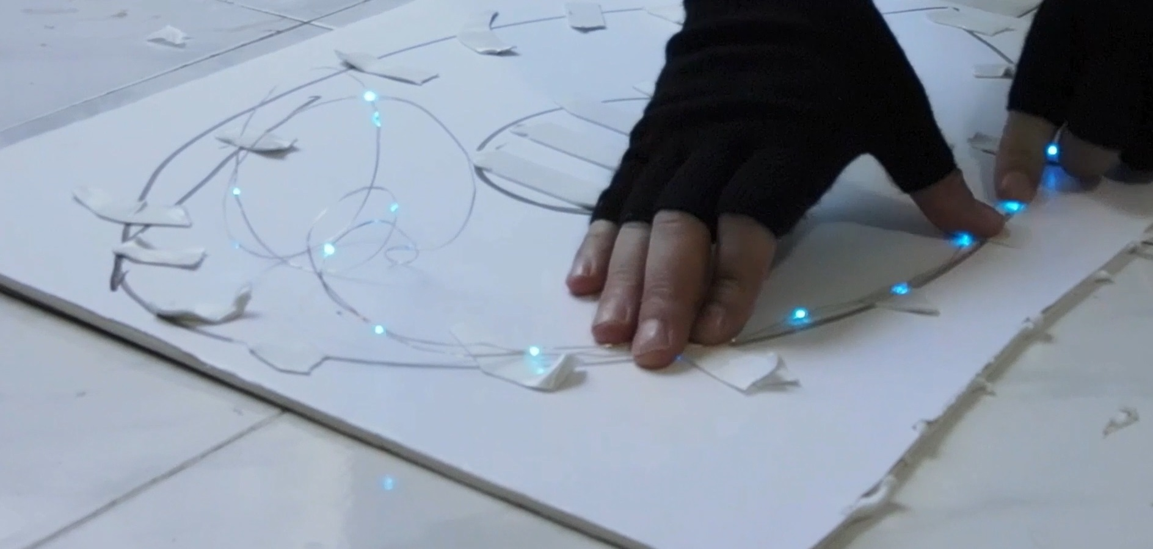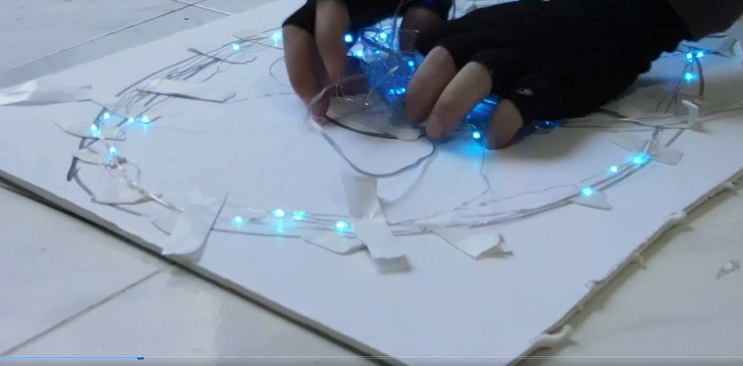

1. Once the LED string light is attached to the board in the right shape we use transparent glue to attach it permanently (the double-sided tape is only for temporary attachment). Make sure to add glue to attach the string at a small distance along the shape. Make sure you are not covering the LEDs lights. Transparent glue is good for this as it gives a nice diffusion effect once the LEDs are on. We use Hybrifix Super 7.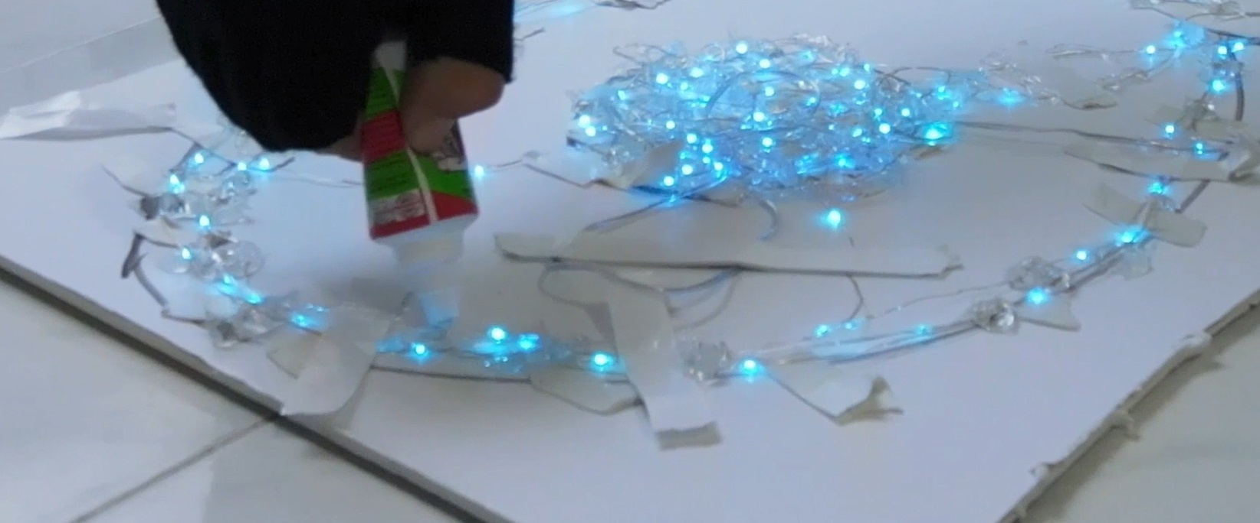
2. The next step is attaching the Solar Cell battery to the board. The buttons that control the light are usually in the back of the cell. So once the Cell is attached to the board you will not be able to reach them. Make sure to turn on the LED and pick the right light pattern beforehand. Note the cells only activate when it is dark so if you want to see the pattern at day just cover the solar panel with your hand and it will be activated.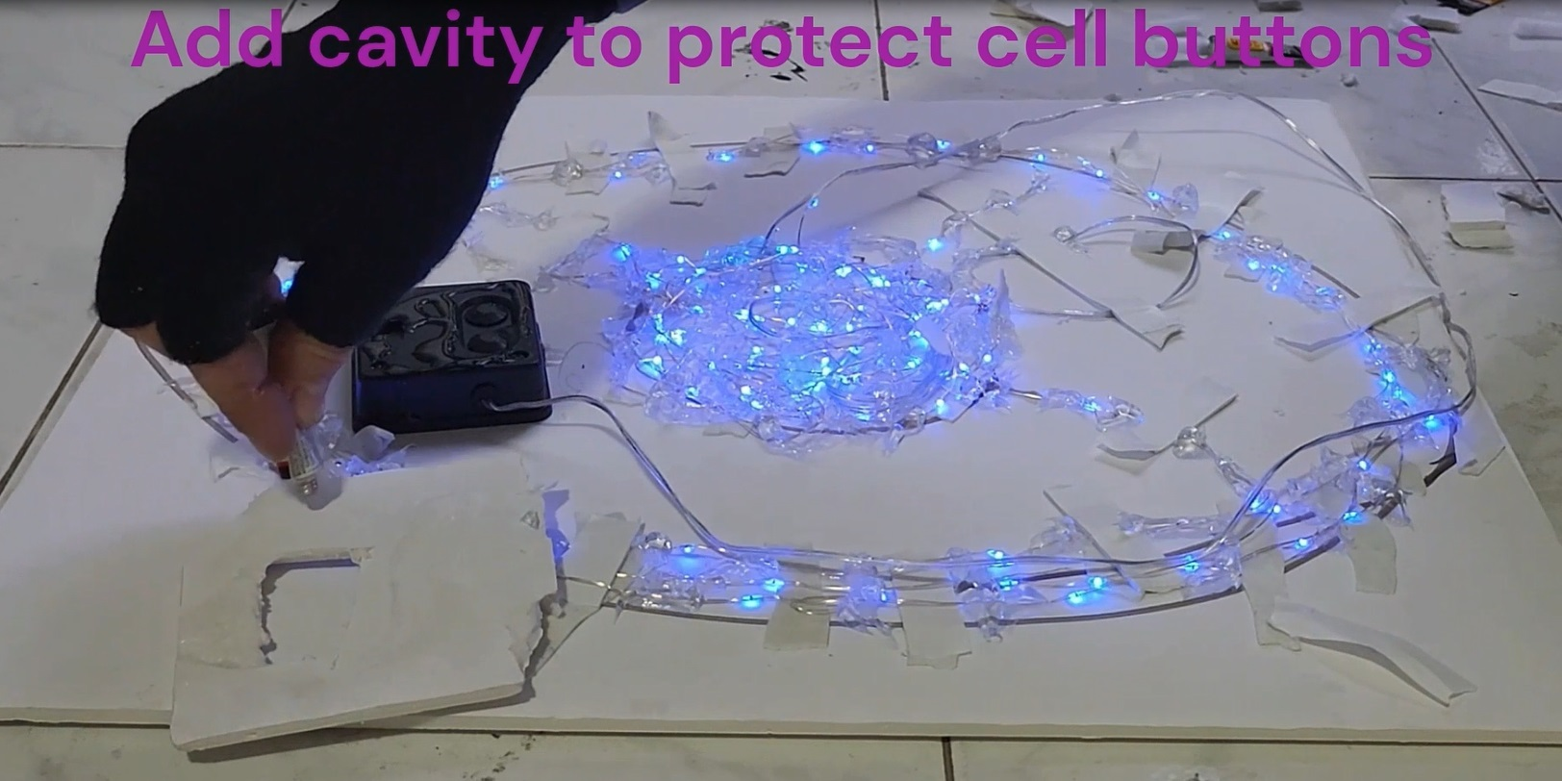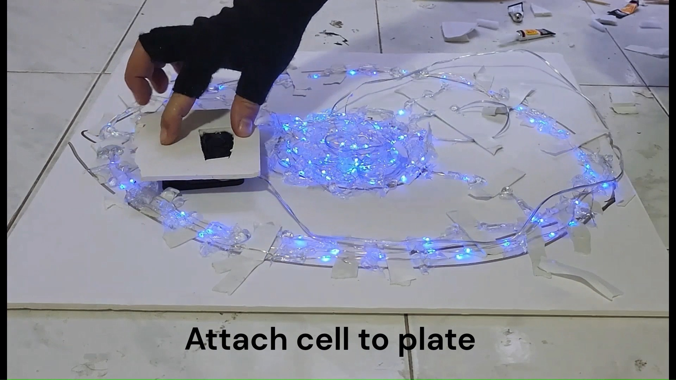
3. Since the buttons of the solar cell are at the back pasting the back of the cell to the board might cause the button to accidentally be pressed. To avoid this we create a cavity to protect the buttons. Cut a piece of Kappa (or any board you use) in the size of the Solar cell. In this piece, cut the cavity for the buttons, then stick the piece to the Cell back using superglue (make sure the buttons are in the cavity). Then attach the all pieces to the board again using superglue. Note that for weight balance you want the cell to be as low as possible, but preferably at the side as in the center it might integer with the hanging stick that will be used to hold and lift the plate to the wall. 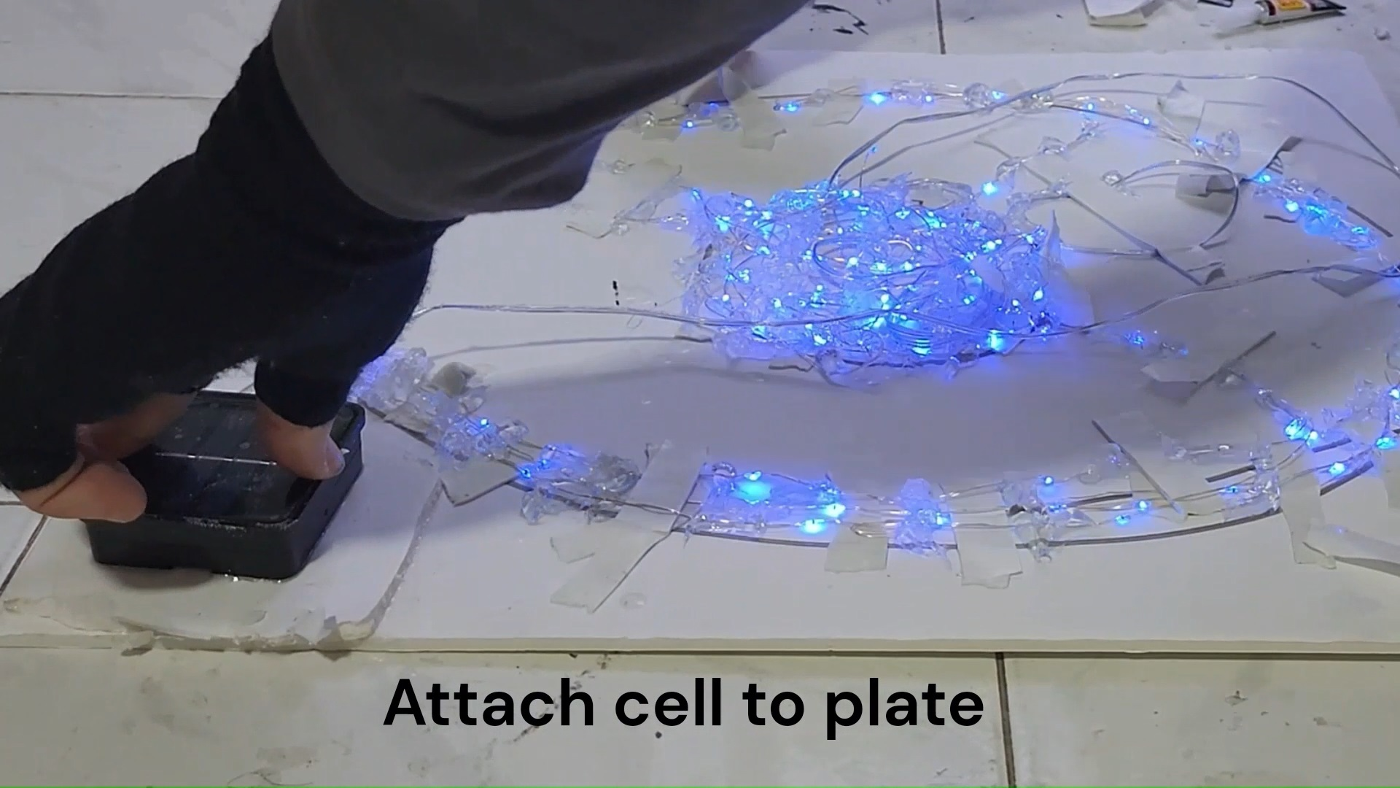
4. Painting the board is optional, but be careful not to cover the LED lights or the solar panel.

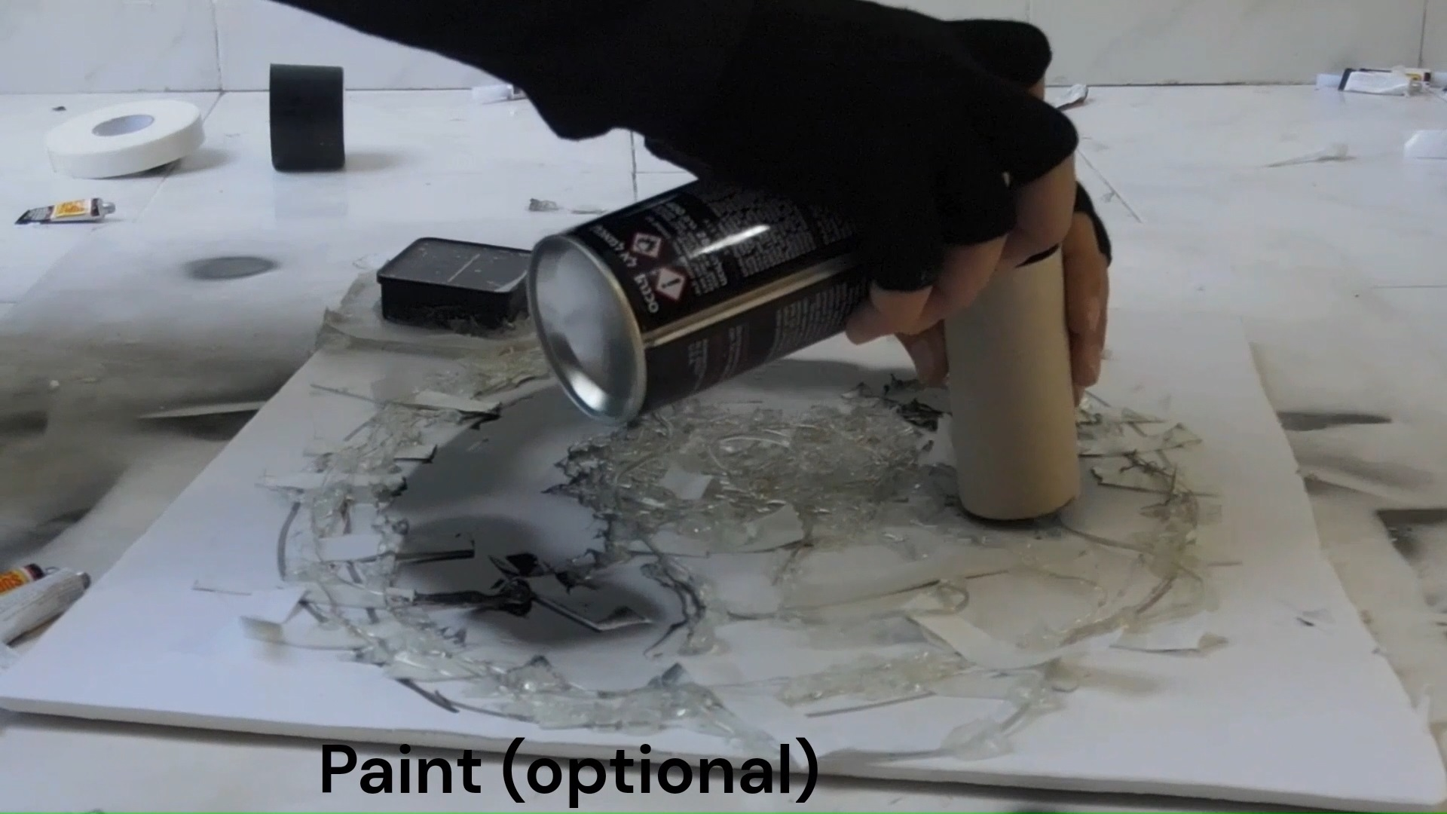

Prepare plate for mounting

The next part is adding a ring that will allow the hanging stick to hold to the board and lift it. The trick is that the ring should allow the hanging stick to hold the plate when it goes up. And once the plate is stuck to the wall release it as it goes down. This means the size of the ring should match the engine stick so it can be lifted stability, and at the same time allow the hangin stick hook to slide out smoothly once it stuck.

This is only relevant if you want to hang the board in really high places beyond your reach. Else avoid this step and jump to step 3

1. We used a zip-tie to create the hanging ring: At the center bottom create 2 holes side by side in a distance of about 5-10cm and pass the zip tie in them as seen in the image (the distance is flexible and should match the hanging stick). Keep the zip tie loose as you can always tighten but not untighten. The distance from the bottom should be about 5-15 cm. The main goal is that the size holder of the hanging stick should be able to hold the plate in a relatively stable way but still slide down easily (see video). Take this into account while making the hanging stick (next section).

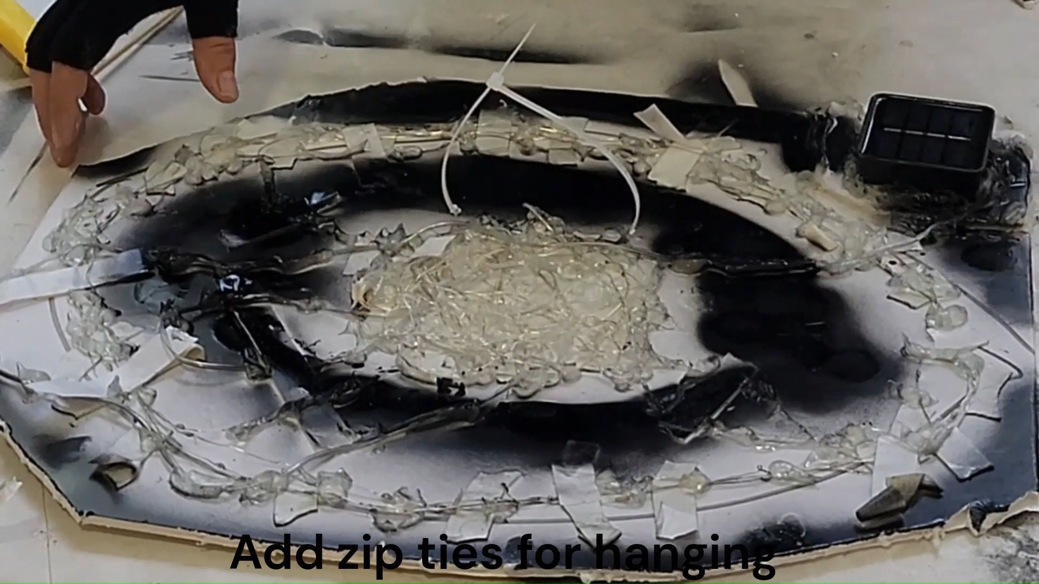

2) For stability it's possible to Add more than one zip tie (3 is a good number).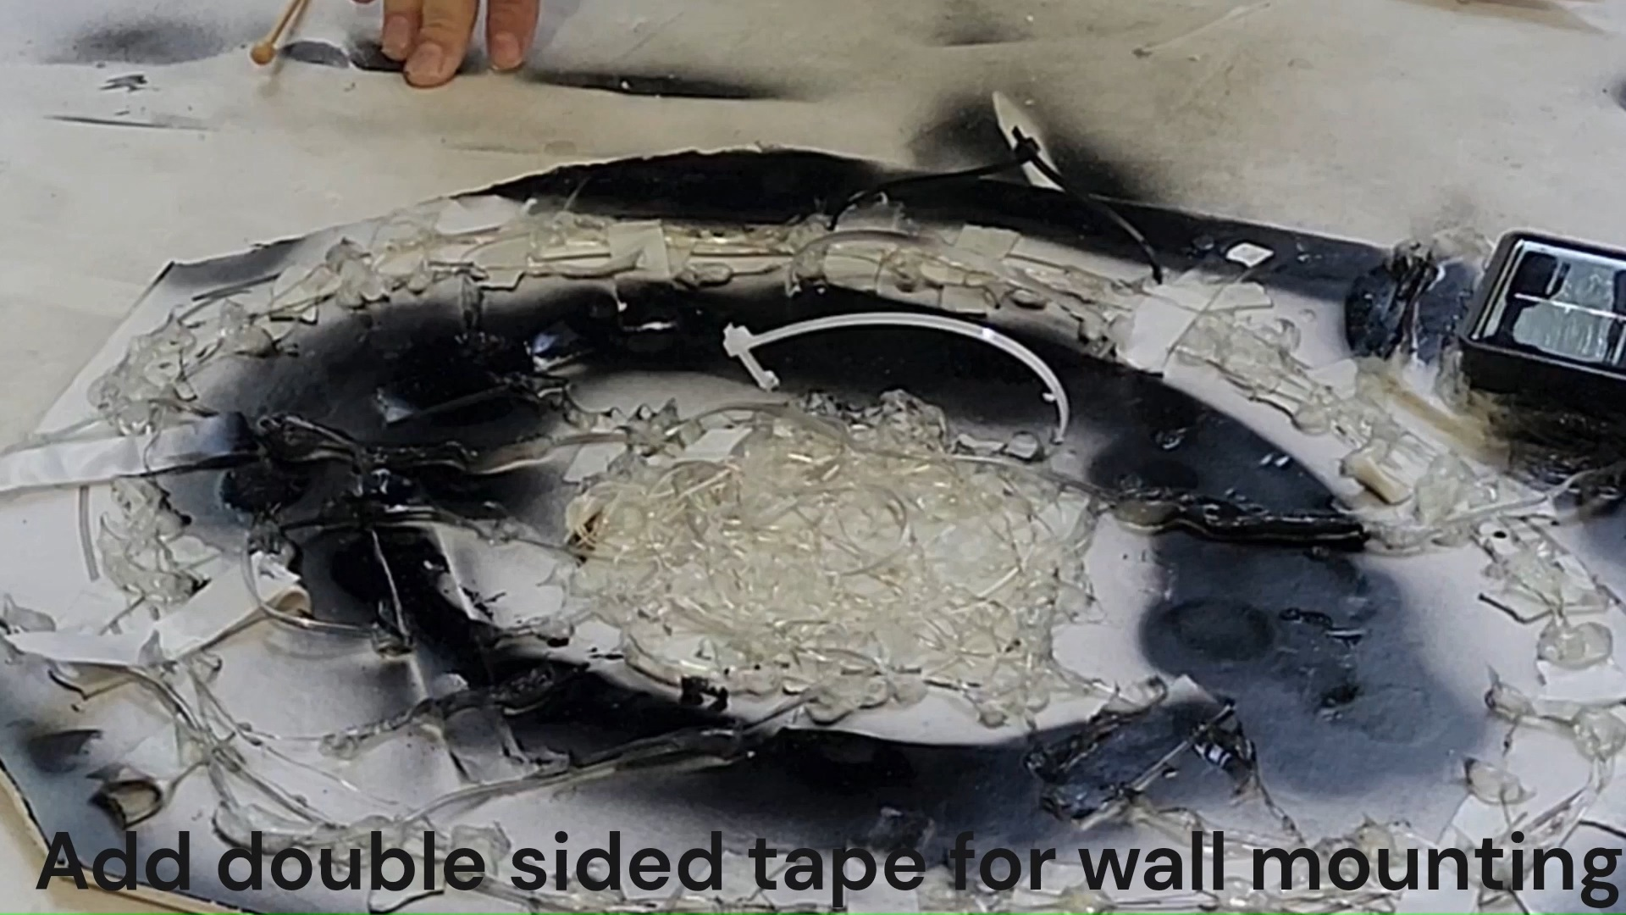

3) Add stripes of double-sided mounting tape to the back of the plate, simple foam mounting tape works well. Make sure you cover the back side of the zip ties. Make sure to leave space for glue between the stripes (5-10 cm is a good distance). Finally thickness of the tape is important and adding two layers of tape one on top of the other really helps stickiness on rough surfaces (avoid paper thin double side tape as it doesn't stick to many surfaces).

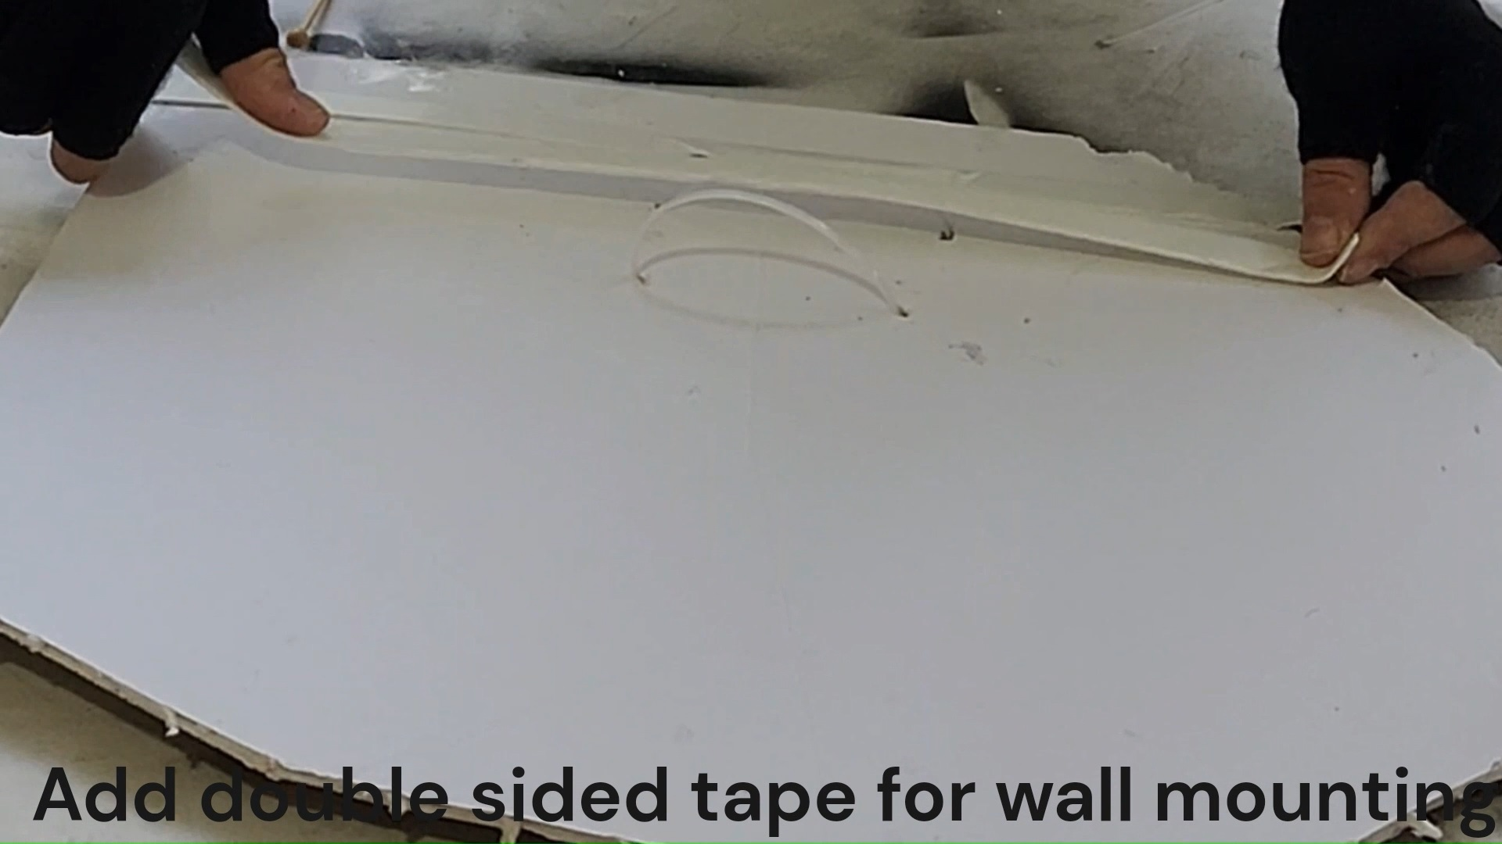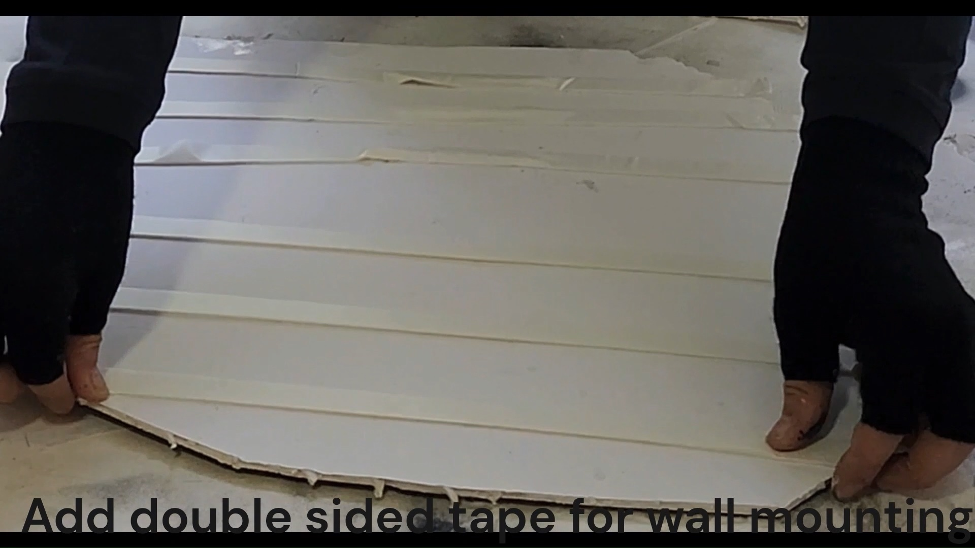

**Making Hanging Stick**

This part is only relevant if you want to hang the plate in really high places way above your reach.

First, we create the holder hook that will hang the plate, this basically the hook around on which the plate will be hung. The important part is that the size of the holder should match that of the plate ring. Will be able to hold it in a stable way and slide out smoothly.

1. For the holder, we mount the sticks in the grid pattern in the image using super glue. The Size should match the tie on the plate (previous section). Any sticks will do as long as they are strong and light. We used Bamboo Skewer sticks (used for barbecue) and arranged them in a grid at a distance of around 5cm each (See image).

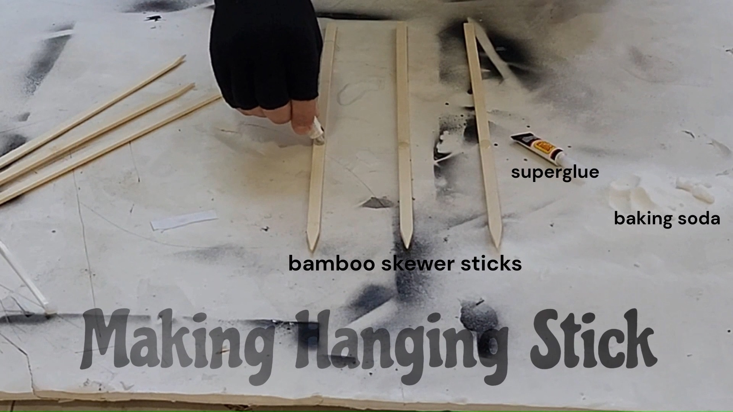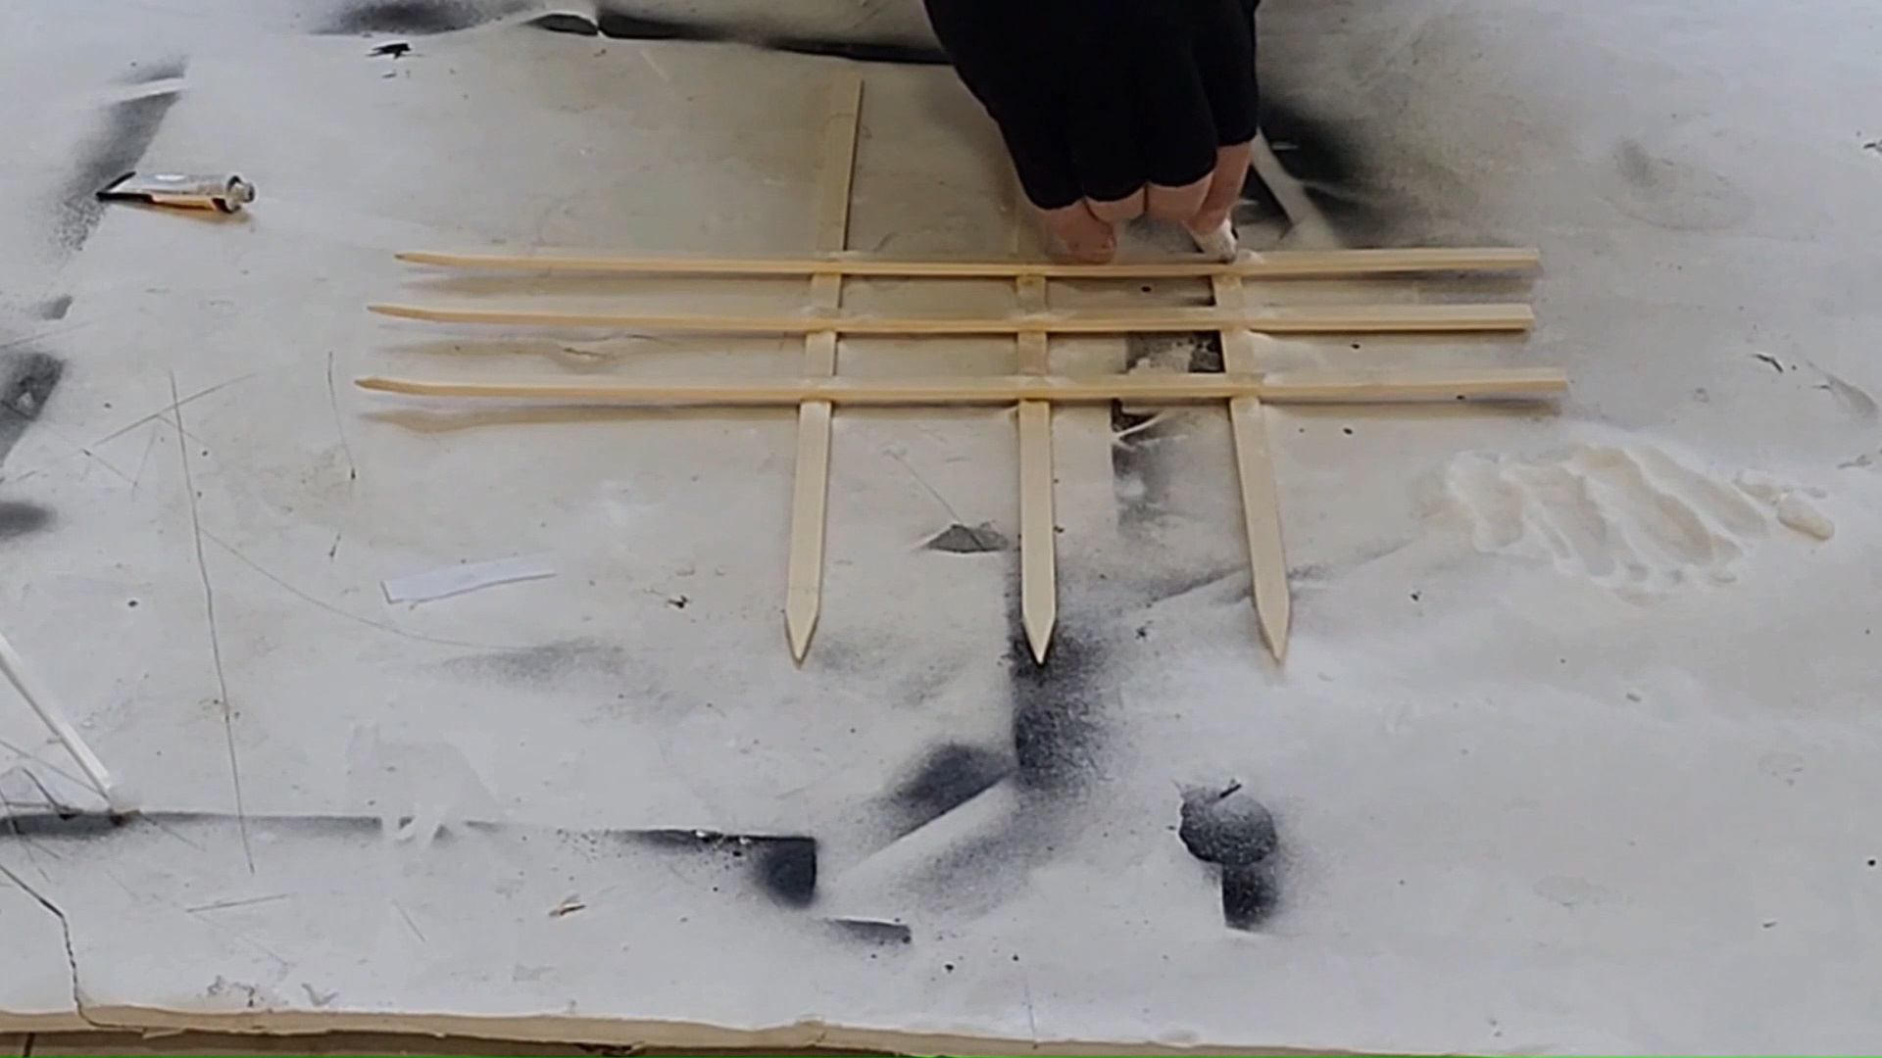

1. Make sure the holder matches the size of the zip tie loop on the board and can slide in and out smoothly.
2. Attaching the holder to the stick. Take the selfie stick and extend the top part, add a stripe of double-sided mounting tape, and attach the holder to the stick (image).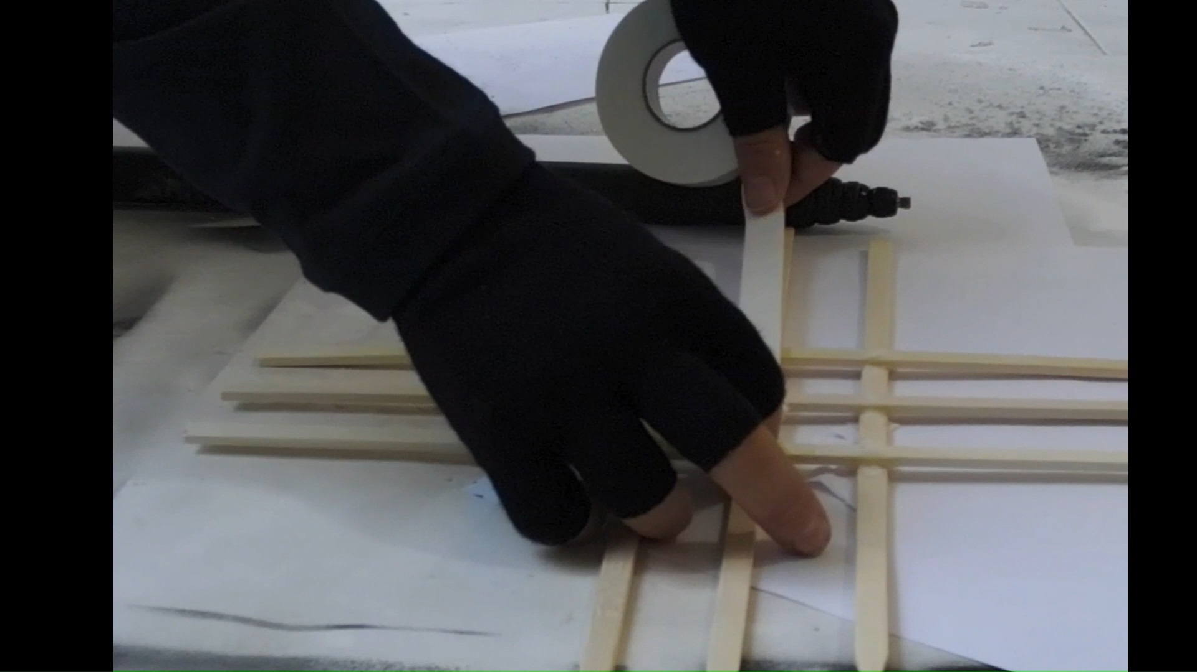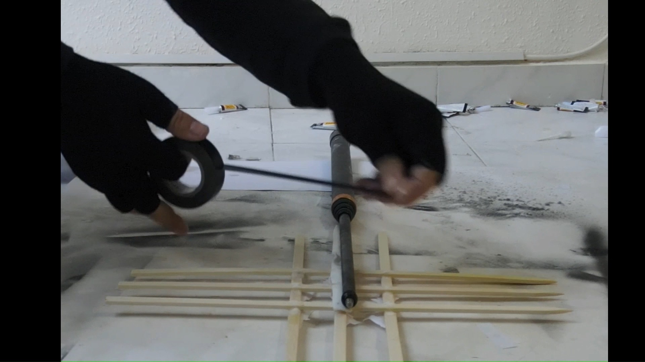
3. Wrap PVC tape to tightly hold the holder hook to the the stick. 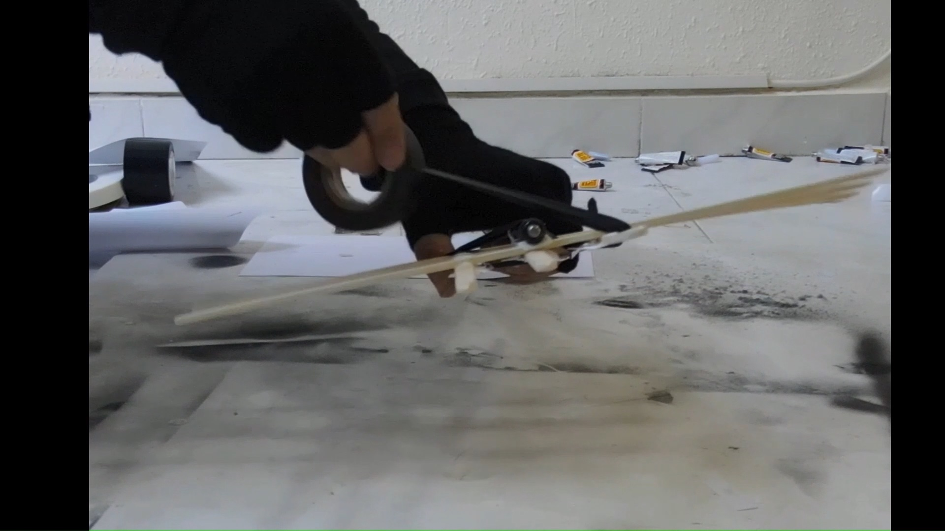
4. Try to make it such that the smooth side of the holder will be pointed outside, as it will help the holder slide out of the loop during hanging.

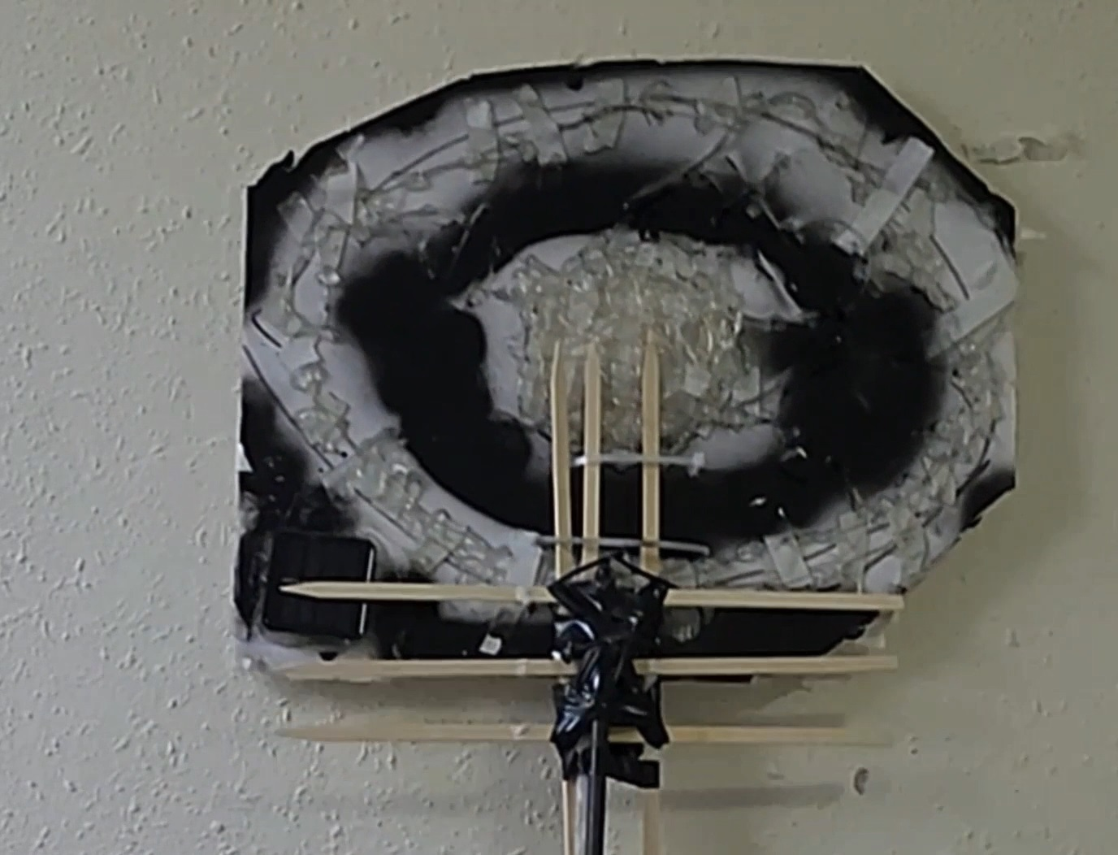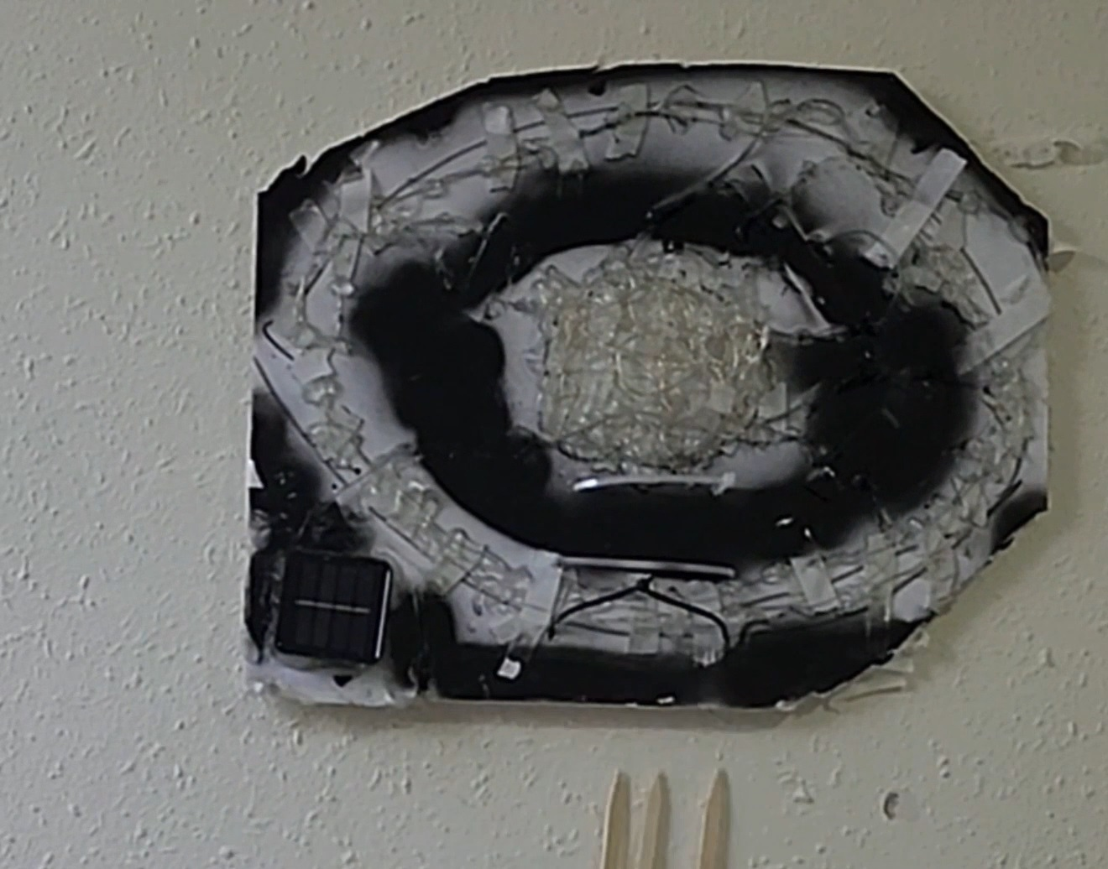

**Hanging**

Hangin is pretty straightforward.

1. Extend the selfie stick and lock it.
2. Remover liner and uncover the mounting tape at the back side of the plate
3. Add some glue at equal intervals on the back side of the plate.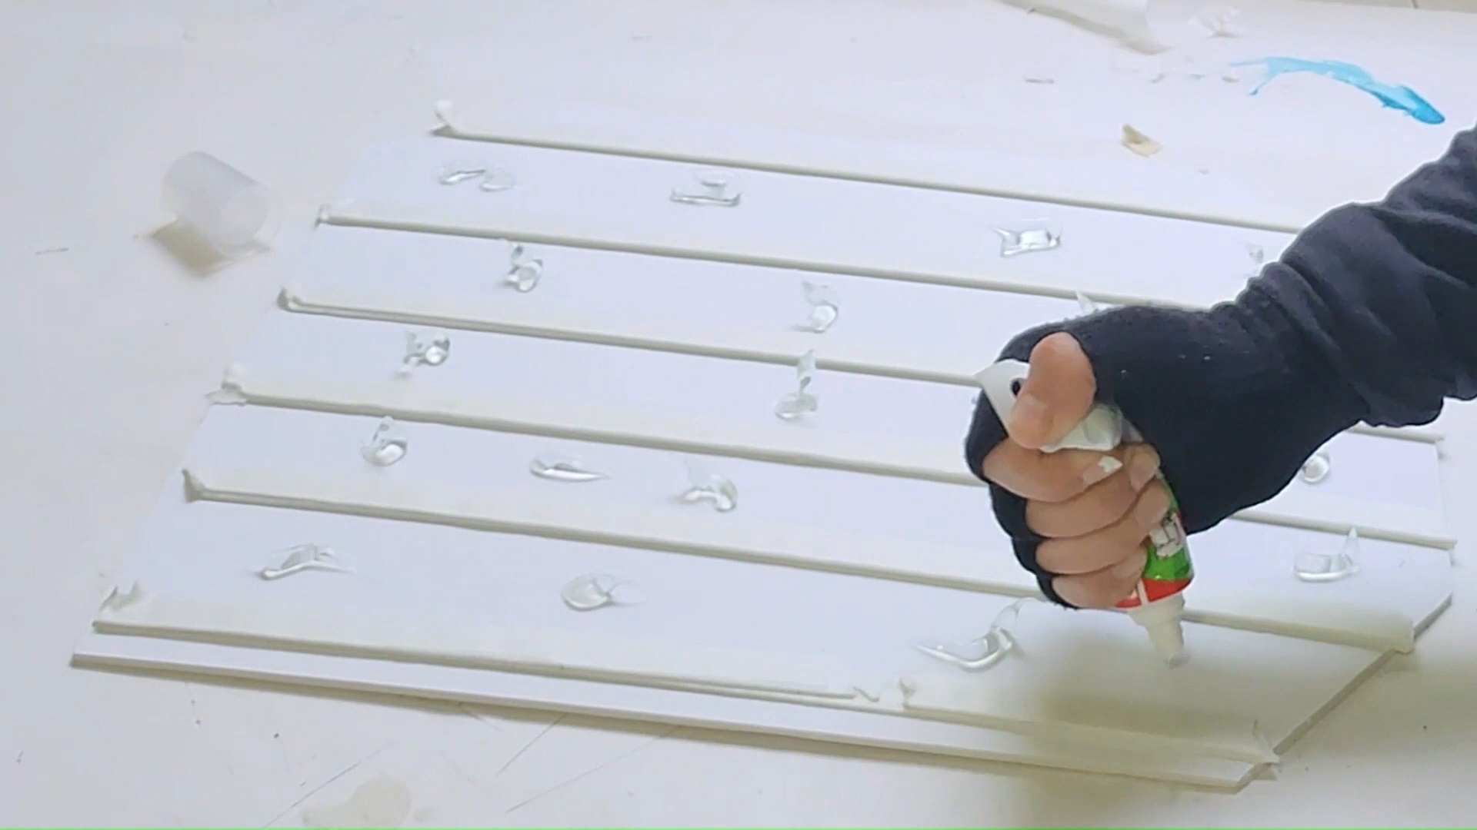

The double-sided tape is for immediate mounting and the glue is for more durable long-term mounting)

1. Hang the plate on the holder lift it and push it to the wall and slide the stick down for release.

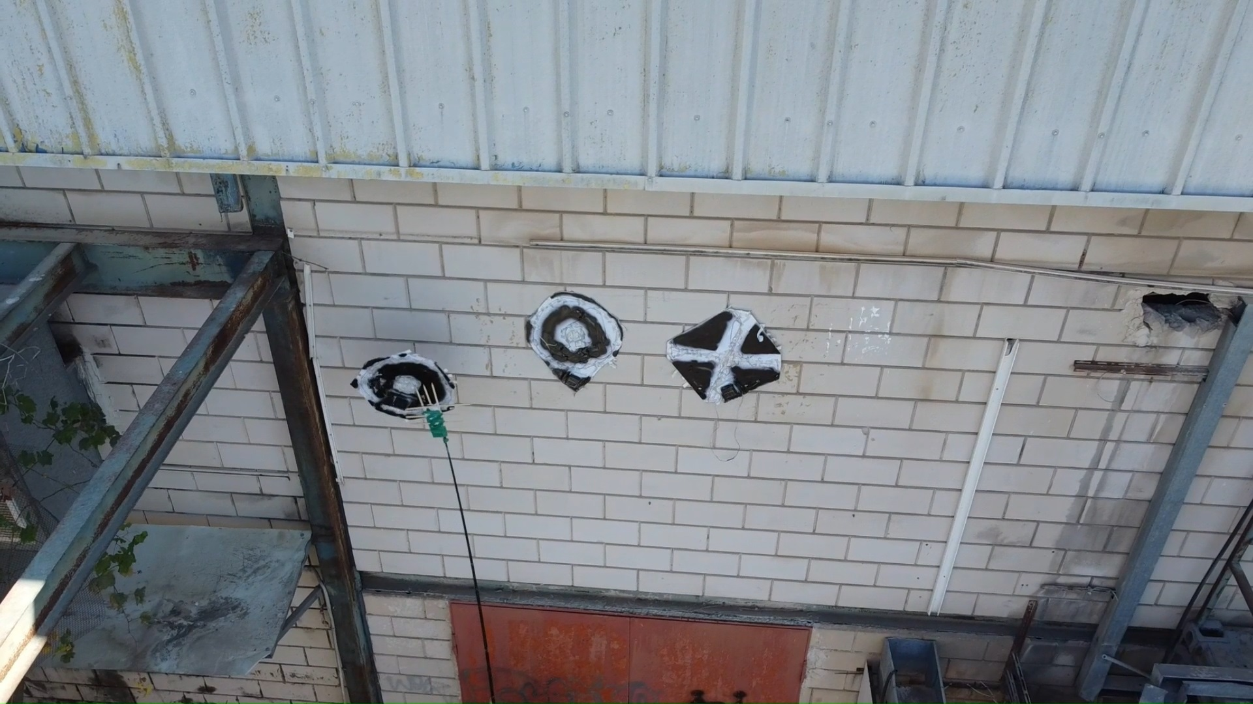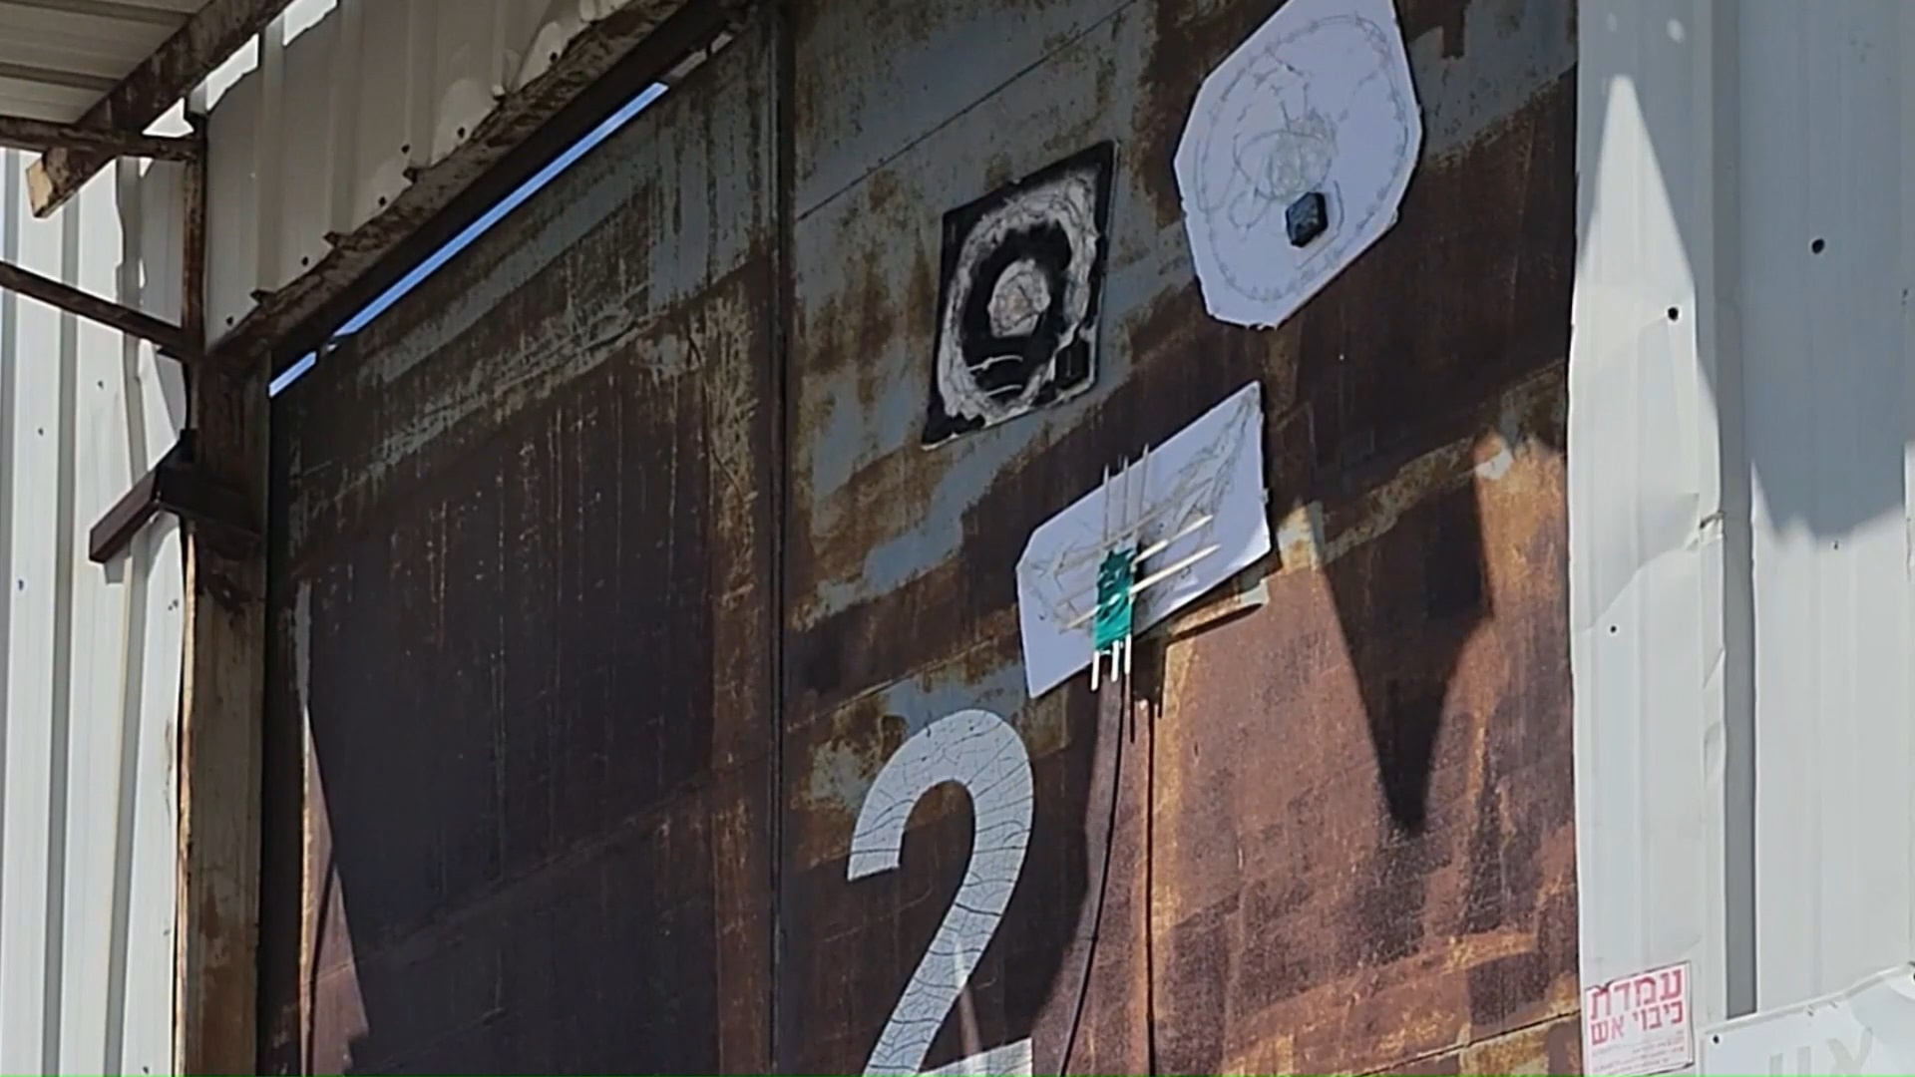

6) After releasing it is recommended to use the holder to press the plate for the wall in different positions (making sure it is attached across the entire surface).

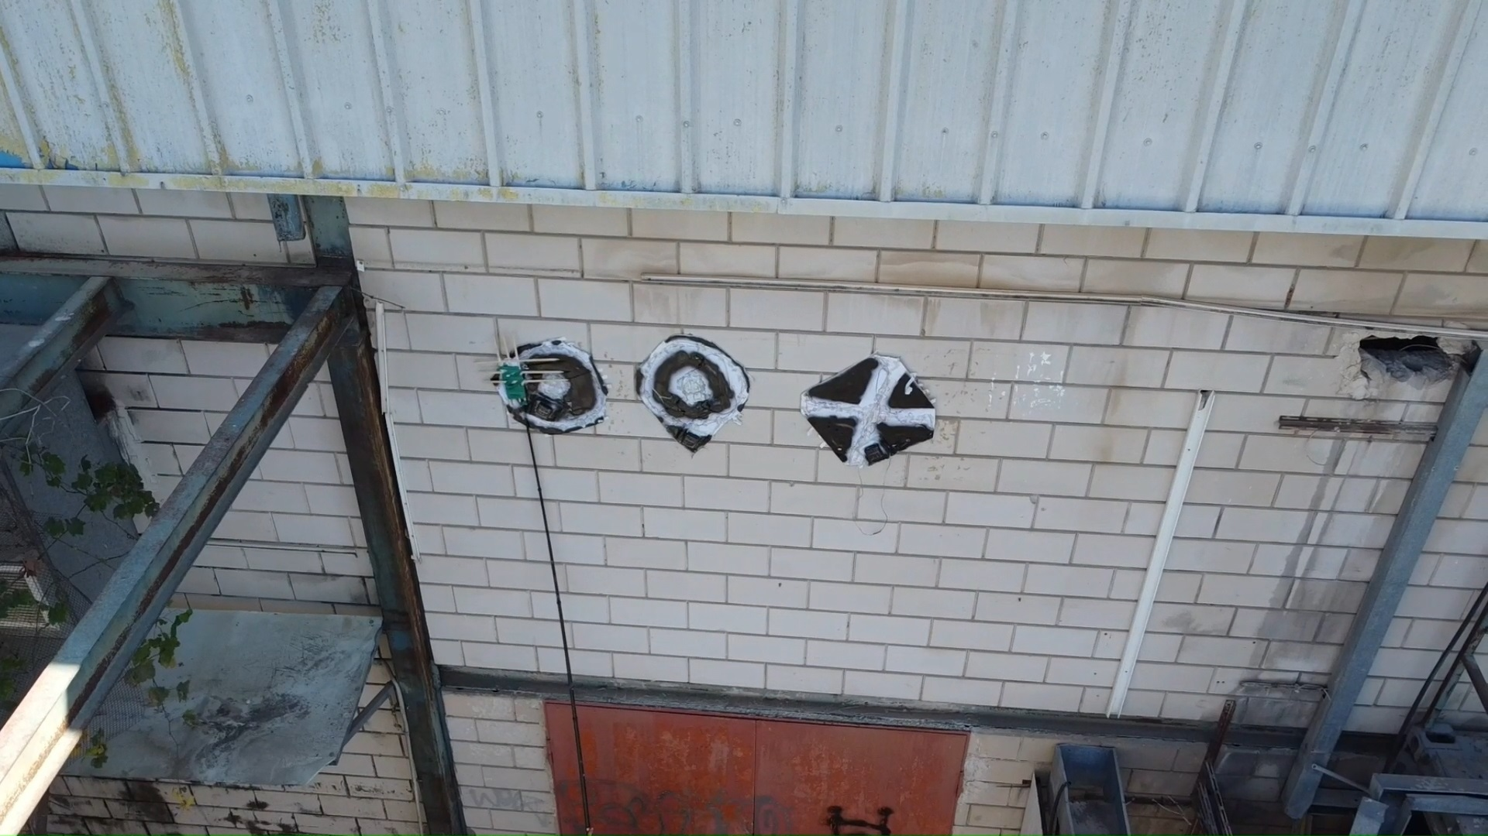

**Results:**

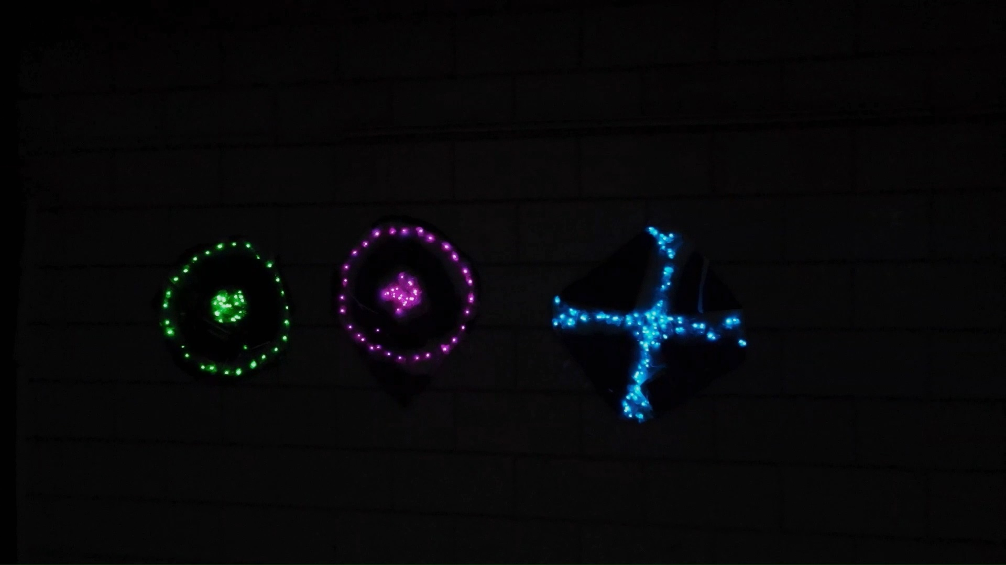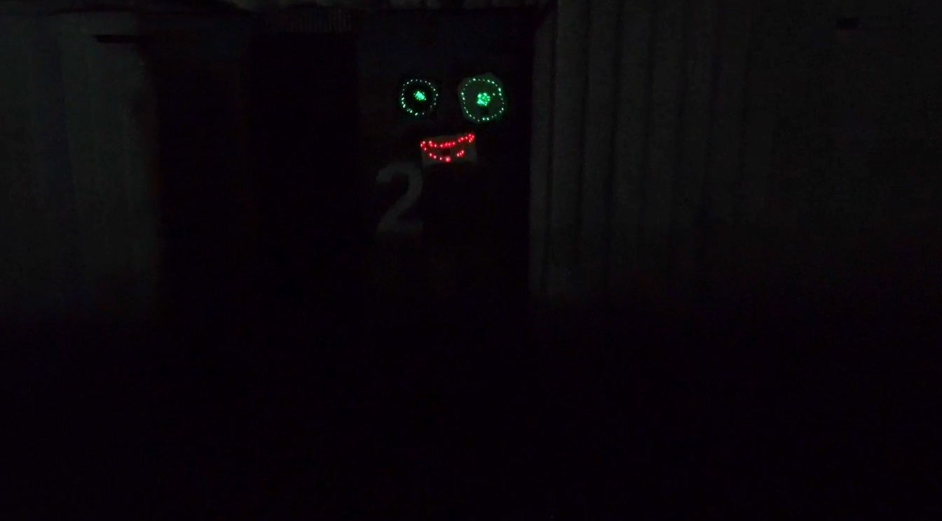

**Troubleshooting.**

1. Remember this uses the sun to charge so having a spot of direct sunlight for at least one hour a day is essential.
2. The main trouble we encountered was that the hanging stick got stuck on the board due to wires or the cell and couldn't detach. Make sure the plate holds the plate stable and slides out smoothly.
3. If the plate fails to stick to the wall you can always add another layer of tape and try again.
4. For rigid surfaces the thicker the tape the better. Adding multiple layers of double-sided tape can help in many cases to improve attachment.
5. Note that selfie sticks mostly go to max 3 meters which means max hanging height for most people is 4-6 meters. For higher paces, we need to use drones, but this is for another time.